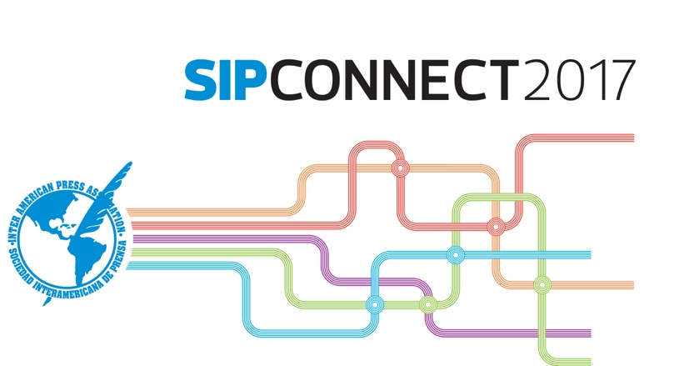

WEDNESDAY June 21

8:30 - 9:00 a.m.
Welcome!
> Matt Sanders, Deseret Digital Media, and Ricardo Trotti, Inter American Press Association (IAPA)

9:00 - 9:45 a.m.
Opening presentation
How to tell more visual stories in the digital age
> Mario García, García Media, New York, N.Y.

9:45 - 10:15 a.m.
Presentation
Digital resources to sell more on paper.
Feedback between the two platforms.
> Mike Blinder, Blinder Group, Tampa, Florida

10:15 - 10:30 a.m.
Coffee break

10:30 - 11:45 a.m.
Segment I: Different styles of digital transformation
Every news company is different and the routes that lead to change are various. In this panel discussion there are presented three media, three styles, three strategies that have been experimented and have created their own formulas to position themselves successfully in the new digital environment.
> Matt Monahan, The Washington Post, Washington, D.C.; Sergio Marabolí, editor of La Cuarta, Chile; Darío Gallo, editor-in-chief of Clarín digital, Buenos Aires, Argentina, and Roberto De Celis, Digital News Editor, Grupo Vocento, Madrid, Spain. Moderator: Matt Sanders, Deseret Digital Media.

11:45 a.m. - 1:00 p.m.
Segment II: New cases of success in the monetization of content.
The return of the paywalls.
There is a direct relationship between the decline in readership on paper and the adoption of strategies of being paid for content in the media. The New York Times has already exceeded 2 million digital subscribers. More than half of the United States newspapers have adopted digital subscription models. In Latin America the traditional newspapers continue to join this trend through different types of strategies.
> Billy Aldea-Martínez, Piano Media, São Paulo, Brazil; Javier Kraviez, manager of Clarín, Buenos Aires, Argentina; Isabel Amorim, Grupo Abril, São Paulo, Brazil. Moderator: Mindy Marques, The Miami Herald, Miami, Florida.

1:00 - 2:30 p.m.
Lunch
Keynote Speaker: Víctor Kong, president of Cisneros Interactive.

2:40 - 3:00 p.m.
Presentation
Alexandra Villoch, Regional Vice President, McClatchy Newspapers.

3:00 - 4:00 p.m.
Segment III: Video is the King of Content; we all like it and it gives the best dividends.
From the OTT platforms to the video kiosks and the alliances with traditional television channels and the new 360 or Increased Reality formats; beyond the YouTube universe, the media with success in the digital environment must count on a strategy of modern, clear and convincing videos.
> Carlos Hullet, VivoPlay/TV Venezuela; Johnattan Bilancieri, Cimacast/NTN 24; Darío López, The Associated Press, Mexico City; Eduardo Suñol, Vice President of Digital News, Telemundo. Moderator: Bertha Ramos, CNN Español, Atlanta, Estados Unidos.

4:00 - 5:00 p.m.
Segment IV: Audience loyalty. New ideas to take better care of the heart of news companies.
The technology of media advances day by day. This panel discussion presents recourses to improve the relationship of a media outlet with its public and other tools to add value to contents.
> Alejandro Couce, Vindicia; Gabriel D’Onofrio, Cxsense, Buenos Aires, Argentina; Katherine Haine, President & CEO, CityMedia, Toronto, Canada. Moderator: José Curiotto, Diario El Litoral, Santa Fé, Argentina.

5:00 - 5:15 p.m.
Coffee break

5:15 - 6:15 p.m.
Segment V: Metrics + Social Media = Different Types of Audiences
A story on the Web can have a very big public, but on Facebook it is a failure. Or vice versa. Newspapers are learning to resolve this equation. They require journalists that are passionate, capable of combining the challenge of multiple channels of distribution of content. The daily collaboration to get the juice out of contents in different platforms.
> Métrica Director Eduardo Aguilar and Social Media Editor Renata Sánchez, El Universal, Mexico y Marysabel Huston, CNN en Español, Atlanta, Georgia. Moderator: Alex Herdoiza, El Comercio, Quito, Ecuador.

6:15 - 6:45 p.m.
Presentation:
Classified ads, one of the engines of digital transformation
> Rafael Bonnelly

7:00 p.m.
Welcoming cocktail reception

THURSDAY June 22

9:00 - 10:00 a.m.
Presentation
Everything you need to know about the Facebook Journalism Project and what the company is doing to straighten its relationship and value for the News industry.
> Luis Renato Olivalves and Cláudia Gurfinkel, Facebook, Media Partners LATAM

10:00 - 10:30 a.m.
Presentation
Innovation and imagination in digital platforms
Mauricio Cabrera, creator of the Web site Juanfutbol.com of Mexico

10:30 - 10:45 a.m.
Coffee break

10:45 - 11:45 a.m.
Segment VI: Native Advertising, Sponsored Content and Storytelling: three different concepts that go well together.
It is not few the number of newspapers that are operating departments in charge of producing content and advertising on the basis of these three concepts that can add a new dimension to the business of journalism. What is essential in order to triumph in this is to have the concepts very clear and to adopt the appropriate strategy.
> Eduardo Tessler, consultant, Porto Alegre, Brazil and Mauricio Cabrera, creator of the Web site Juanfutbol.com of Mexico.

11:45 a.m. - 12:45 p.m.
Panel Discussion
New tools and services
Internet 3.0 has brought about a rebirth of tools and resources to produce profits from digital contents.
Panelists: Carlos Martínez, Press Reader, Vancouver, Canada; Marcos Enriquez, LowPost, Madrid, Spain; Héctor Botero, ContentEngine, Miami, Florida

12:45 - 2:15 p.m.
Lunch
The New IAPA Digital Kiosk
Keynote Speakers: Fernando Gómez-Carpintero, Protecmedia, Ivo Cadenas, Digital Transformation Consultant

2:15 - 3:15 p.m.
Segment VII: The Evolution of the Newsroom in 2017
Now they are called content factories. To operate in the sophisticated atmosphere of digital platforms what is required is organization, order and efficiency.
Panelists: Selymar Colón, Digital News Editor, Univisión, Miami, Florida; Eduardo Tessler, innovation consultant, Porto Alegre, Brazil; Sergio Marabolí, La Cuarta, Santiago, Chile; Stephen Ryan, Global News Editor, Deseret Digital Media, Salt Lake City, Utah. Moderator: Néstor Altuve, media consultant, Panama.

3:30 - 4:00 p.m.
Segment VIII: Monetization of mobile content
> Roberto de Celis, Digital News Manager of Grupo Vocento, Spain; Aura Llanas, Marfeel, Madrid, Spain; Jacinto Montu, Unicorn Games, Buenos Aires, Argentina. Moderator: Ernesto Kraiselburd, El Día, La Plata, Argentina.

4:00 - 4:15 p.m.
Coffee break

4:15 - 5:00 p.m.
Segment IX: New trends and concepts in the design of Web sites.
Design is the bares bones that sustains successful digital businesses. This panel discussion explores three recent works of transformation that incorporate the essential new elements of content according to the formats of the various platforms.
Panelists: Iñaki Palacios, Cases i Associats, Miami, Florida; David Torres, Xalok, Miami, Florida. Moderator: José Ignacio García, LowPost, Miami, Florida

5:00 - 6:00 p.m.
Presentation
Google initiatives with news media
It has been a difficult, and at times bitter, relationship but Google and news media are beginning to go on a new path – that of partners on the Internet. “When journalism triumphs we are all better off” is the catchphrase of the Google Initiative for News Partners.
>Matías Attwell, Google director of solutions for Spanish-language media editors in Latin America.

8:00 - 11:00 p.m.
Evening of Art and Music
TheLabMiami in Wynwood
An invitation to SIPConnect 2017 participants from clicLogix Americas.

FRIDAY June 23
9:00 a.m. - 12:30 p.m.
Practical workshop - Media Bootcamp:
To reevaluate the brand in the digital tsunami. Customer loyalty, the key of the news business.
A session of interactive work, based on successful experience related by its protagonists in a “short video” format. Among them all we are going to decode the keys that will make it possible for our brand to continue being a reference in the digital maelstrom and our sustainable business. We will hear at first-hand how Clarín (Argentina), La Dépêche du Midi (France) and El Colombiano (Colombia) are achieving multimedia cultural change in their organization; what El Economista (Spain) has done to increase tenfold its audiences through niche digital products; how Grupo EPENSA (Peru) is increasing its revenues thanks to focusing on content of quality.
César Bracho (Venezuela) and other specialists of the region will explain the methods that are triumphing to achieve engagement with and membership of audiences. We will learn how ABC, a hundred-year-old brand in Spain, is renewing its memberships through the e-commerce project called Oferplan … these and other experiences inspiring loyalty that will mark a before and after in many of the participants. All this in a participatory atmosphere, in which those taking part will have not only a voice but also a vote.

